Pattern Recognition and Machine Learning Programming Lab

| **Ex. No.** | **Date** | **Program**  (Tentative) |
| --- | --- | --- |
| 1 | 31/07/23 | 1. Numpy and Pandas |
| 2 | 07/08/23 |  |
| 3 | 14/08/23 |  |
| 4 | 21/08/23 |  |
| 5 | 04/09/23 |  |
| 6 | 11/09/23 |  |
| 7 | 18/09/23 |  |
| 8 | 25/09/23 |  |
| 9 | 09/10/23 |  |
| 10 | 16/10/23 |  |
| 11 | 30/10/23 |  |
| 12 | 06/11/23 |  |
| 13 | 13/11/23 |  |

**Ex No. 1** Numpy Arrays and Pandas

**Date: 31-07-2023**

1. Write a python program to perform matrix operations on an M x N matrix and solve a system of linear equations. Use inbuilt functions to implement the operations. Get two matrices from the user. The program should support the following Menus,
2. Matrix Addition
3. Matrix Subtraction
4. Scalar Matrix Multiplication
5. Elementwise Matrix Multiplication
6. Matrix Multiplication
7. Matrix Transpose
8. Trace of a Matrix
9. Solve System of Linear Equations
10. Determinant
11. Inverse
12. Eigen Value and Eigen Vector
13. Exit

2. To create tables and do some basic operations on it using Pandas library.

* Create a csv file using python script with the following content

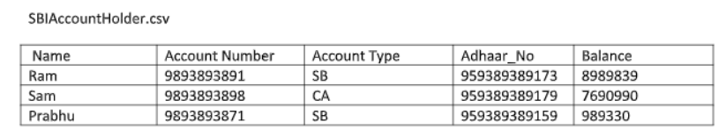

Write a Menu Driven program to support the following functionalities

1. Append Record (row) of account holder
2. Delete Record, given the account number
3. Credit : Ask the user to enter the amount to be credited, and then add it to the balance.
4. Debit : Ask the user to enter the amount to be debited, say x, and then subtract it from the balance. In case of SB account type, debit operation should report an error if **(balance-x) < 0** .
5. Print Account details given the account number.

**NOTE** :

After each operation done on the table (DataFrame), the table should be converted into csv file with the same name.